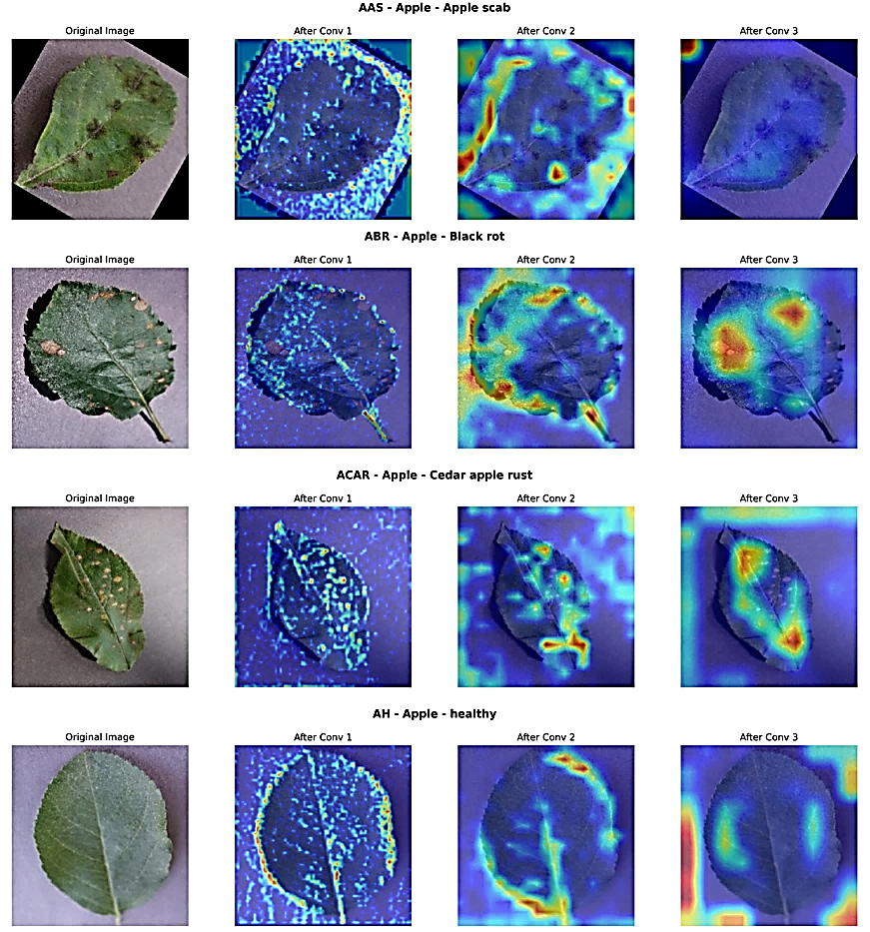
Fig. 4.4 Feature Extraction Visualization of Apple Leaves

